What are: source/encoder/modulator/transmission channel/demodulator and decoders?

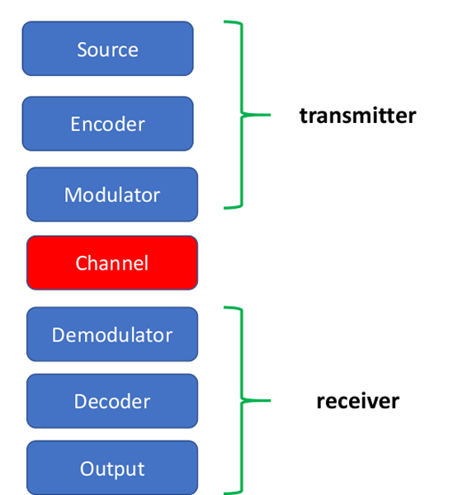

Source: generate signal.
example: cosine/sine wave, samplers (choose signals at some points), converters (transform signal into electromagnetic waves)

Encoder: use rules to encode the signal in the correct way. It is the block that decides the way in which we have to transform the signal

Modulator: changes the signal to be transmitted, it chooses a more suitable signal according to the appropriate criteria (bandwidth, errors, interference of channels, …). A modulator can be of various types (AM [Amplitude Modulation], FM, FSK, …). It requires a demodulator to exist.

Transmission channel: deal with distortion and noise of the signal

Demodulator: recognise the transmitted signal and reproduce the original one, it converts the modulated signal back into the original one. It requires a modulator to exist.

Decoder: do the opposite work of the encoder.

Source, encoder and modulator are part of the transmitter: they converts the message signal produced by a source of information into a form suitable for transmission over the channel

Then we have the channel, which transports the message signal and delivers it to the receiver. During the transmission the signal is distorted due to channel imperfections. Then noise and interfering signals are added to the channel output. The received signal is a corrupted (because of distortion and noise) version of the transmitted signal.

Finally we have the receiver (made of the demodulator, decoder and output) which receives the signal and produces an estimate of the original message signal for the user information.

In which way a signal can be transmitted?

- As it is (AM, FM radio)
- Sampled: periodic samples taken once in a while (telephone)
- Quantized: not all possible values but a finite set of value, a quantized signals make a transmission more robust to noise
- Encoded: with protection and error correction codes
- Encrypted: “secure” transmission (for credit card data)

What is a signal?
A signal is defined as a function/distribution of an independent variable (identified with time or space).
A signal is always real. We can use complex numbers for mathematical manipulations.
Examples of signals:
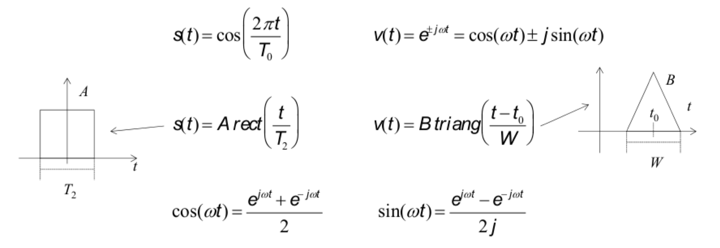
T = period of the signal.
Rectangular wave signal is used for transmitting voice messages.
Complex signals are made of compositions of simpler ones.

How is a signal classified?
- Time-continuous vs time-discrete:
  - Continuous (noise, car speed…):
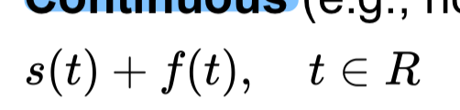
  - Discrete (morse transmission, temperature detected by a sensor…). In this kind of signals, in the points not considered, the signal does not exist:
- Periodic vs aperiodic:
  - Periodic: a signal is defined periodic when there is a value for which the signal repeats, then after a period of time T₀ I have the same signal as before:
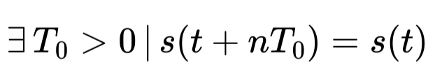
(They are defined in terms of their period T₀ or the inverse which is their fundamental frequency f₀. The positive integer multiples of f₀ are called harmonics. We can also talk about fundamental wavelength, 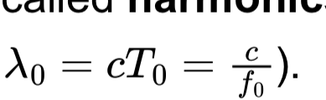
- Aperiodic: a signal which is not periodic.
We can decompose a signal in its periodic and aperiodic parts to get information about changing behaviors that are not regular.

- Deterministic vs random:
  - Deterministic: a signal which is completely known, it can be predicted (signal transmitted from a fixed-frequency source…)
  - Random: we only know the probability that the signal takes a certain value (noise, grade of an exam…)
- “of power” vs “of energy” (both related to square signal):
  - “of energy”: a signal is said to be “of energy” (rect signal) if there exists finite the following integral:
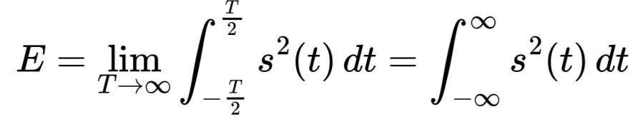
- “of power”: a signal is said to be “of power” (cos signal) if there exists finite the following integral:
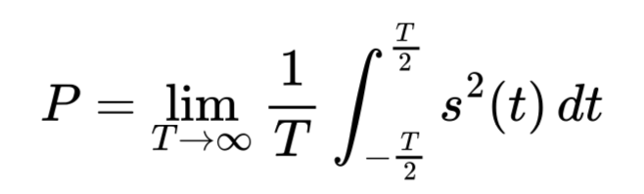
(NOTE: an energy signal cannot be a power signal, and vice versa)

Fourier Series
We can write a periodic signal s(t) in a series form, aka as a sum of sinusoidal components. A Fourier series is a mathematical tool used to represent a periodic function as a sum of sine and cosine functions. A periodic signal is the combination of a discrete set of complex functions of harmonic frequencies (aka sine and cosine).

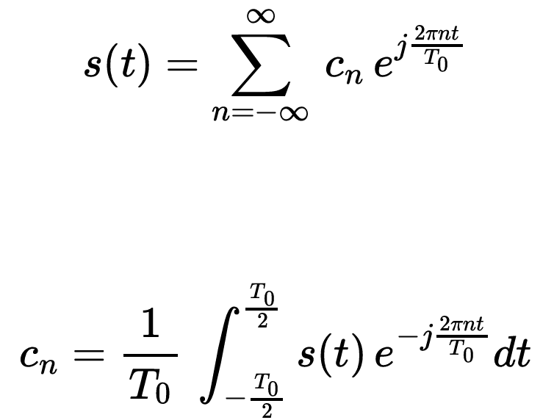
Where:


C_{n} are the coefficients of the signal. These coefficients are complex numbers that represent the amplitude and phase of the sinusoidal components at different frequencies.

C₀ is the 0-th coefficient, it represent the constant part of the signal and it corresponds to the average value of the signal $\underline{s}$ (also called DC component)

Given a representation of the continuous periodic signal of time:

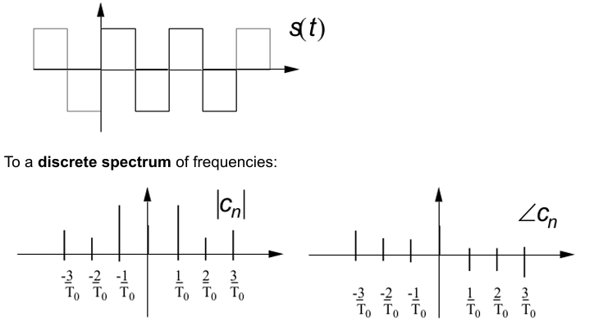

We can obtain a discrete spectrum of frequencies:

The columns of the graphs correspond to coefficients of the fundamental frequencies in which the signal is decomposed. The frequencies may be common to different signals, but what changes is the contribution of each of these to the overall signal.

- The left side shows the real part (modulus) of the spectrum. The greatest positive frequency with a non-zero coefficient is called band (3/T₀)
- Right side shows the imaginary part (phase).

Rectangular Pulses
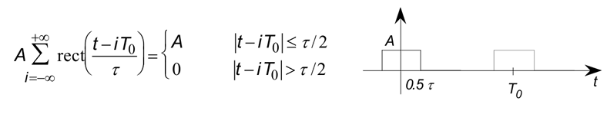

We get
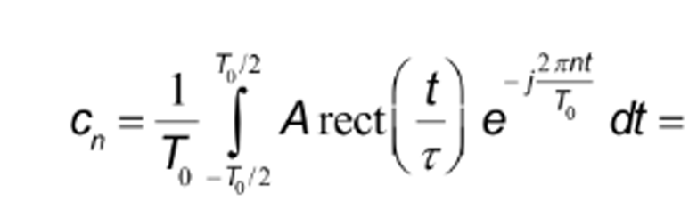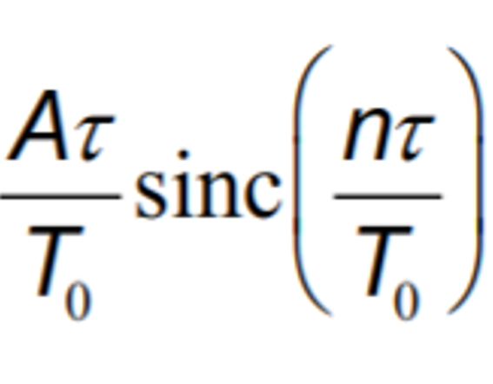

Time-Frequency Relationship
- Shorter signal: higher contribution of high frequencies to its spectrum. Aka wider spectra
- Longer signal: narrower spectra

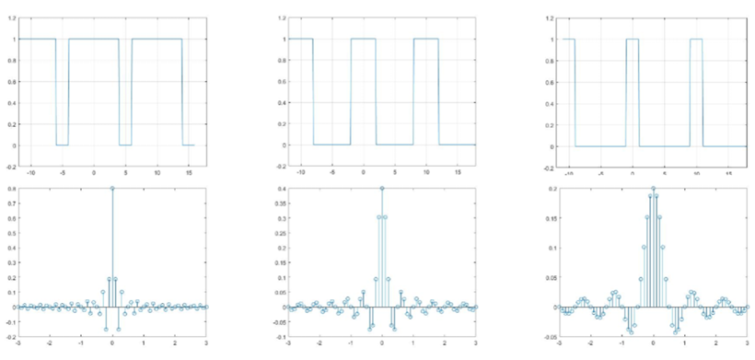
Fourier transform: convert a signal from the time domain to the frequency domain (and vice versa).

The fourier series of a constant signal is the 0 frequency component C₀ (aka the average of the signal). Since the signal does not change, it is equal to the amplitude of the function itself.

Fourier Series - Sine/Cosine Form
Thanks to the transformations given by Euler’s formulas:
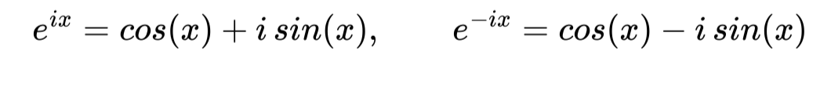
we can describe Fourier series in a different way:
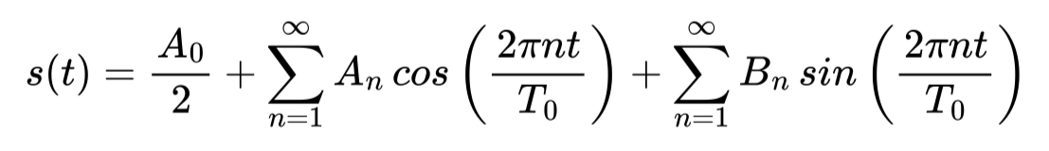
where
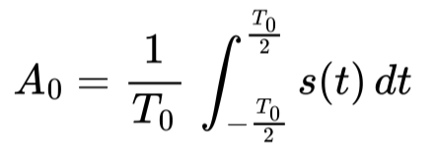
and
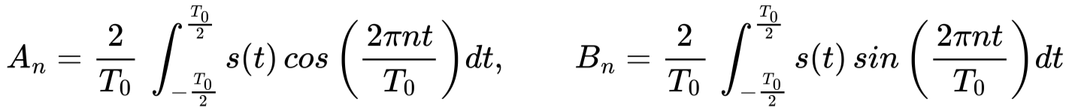
This notation is very useful:
- the coefficients are real;
- sine and cosine have only positive frequencies as arguments → the series in this form has a monolateral spectrum. (Spectrum is only in the top-right part of the Cartesian plane).
In particular,
that is,
- the cosine function is even, it represents the “even part” of the signal
- the sine function is odd, it represents the “odd part” of the signal
Since they have these symmetry properties, it is not necessary to consider the negative frequencies.

Fourier Series - Cosine Only Form
This useful formula is using only cosine:
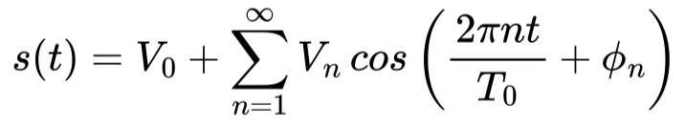
where
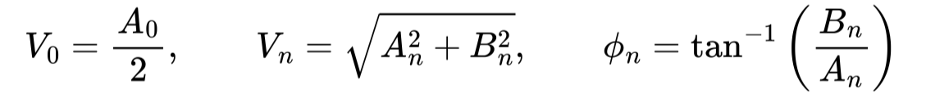
This graphical representation explains the relationship of this form with the trigonometric (sin/cos) form:
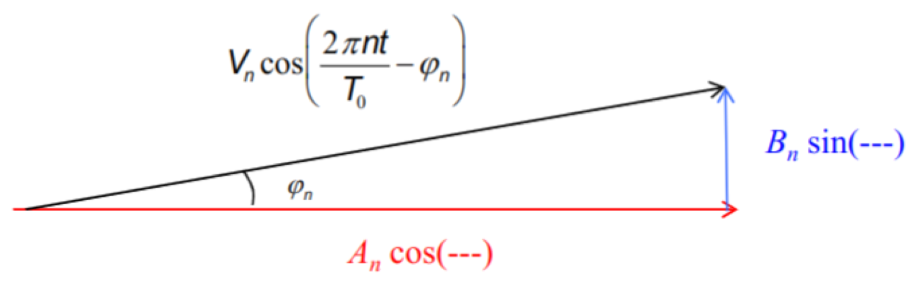

Fourier Series - Dirac Delta Form
We can think of a series of rectangular pulses and consider smaller and smaller pulses (in this example, smaller 𝜏), approaching the limit of area equal to 0, we use the Dirac delta function or unit impulse, defined by
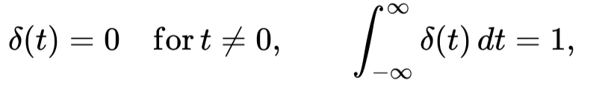
which is an even function of time, to define the limit:
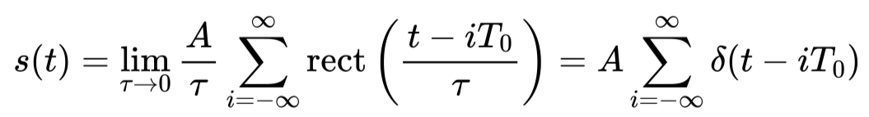
A = amplitude
The derivative of a rect signal is a periodic Dirac delta (impulse) signal with amplitude equal to the amplitude of the rect.
The area of each pulse should approaches zero, as 𝜏 approaches zero, but the height increases such that the product of height and width remains constant (equal to 1). With lim → 0 each rect function becomes narrower but taller, approaching a dirac delta function.
Thus, the signal 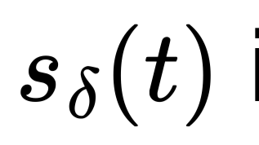is periodic:
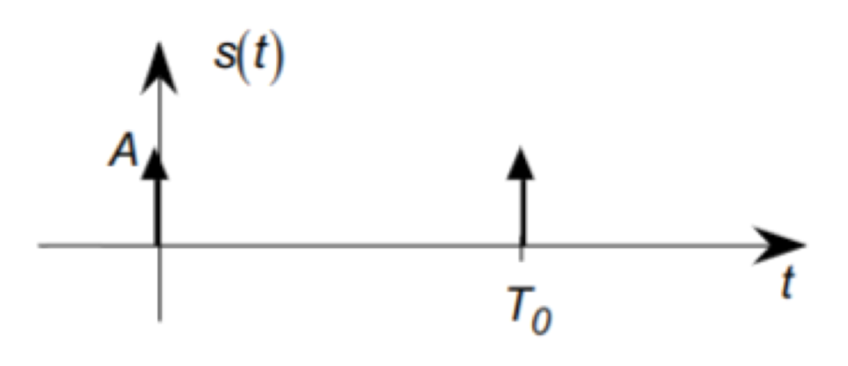
And it has the following coefficients:
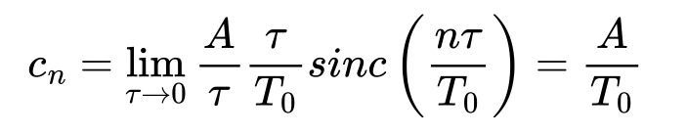
The coefficients of a unit pulse train are equal for all frequencies.

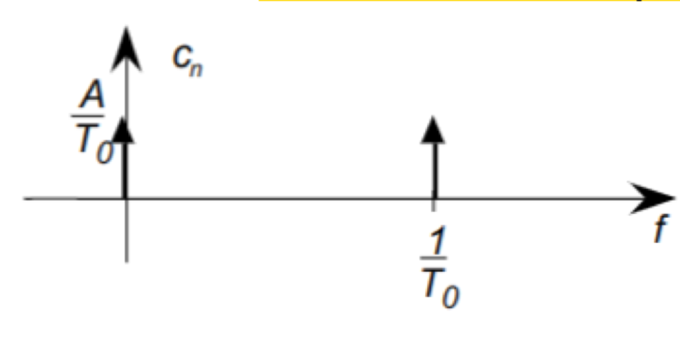
NOTE: Dirac delta function also has the following properties:
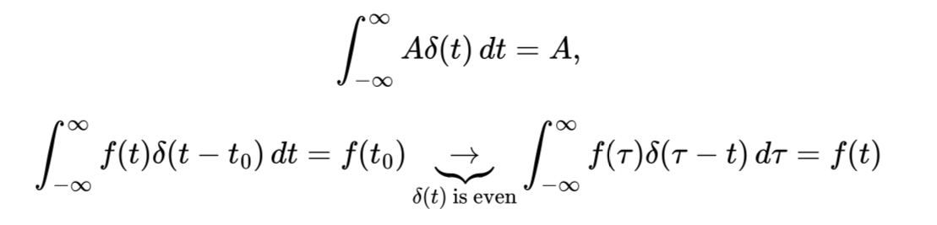
The right-side integral represents a convolution. It follows that
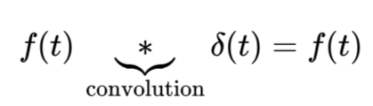

Properties of Fourier Series
Fourier series has the following properties:
- Fourier Series of a constant: the Fourier series of a constant signal is only the 0 frequency component, i.e. the average of the signal (since the signal does not change), which is equal to the amplitude of the function itself:
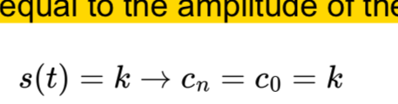
- Linearity: the coefficients of the linear combination of two periodic signals are equal to the linear combination of the coefficients of the original signals: 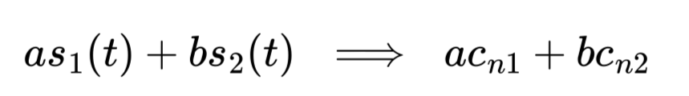
- Delay/Anticipation: the coefficients of a time-shifted signal are equal to the coefficients of the original signal multiplied by a complex exponential (they are phase shifted):
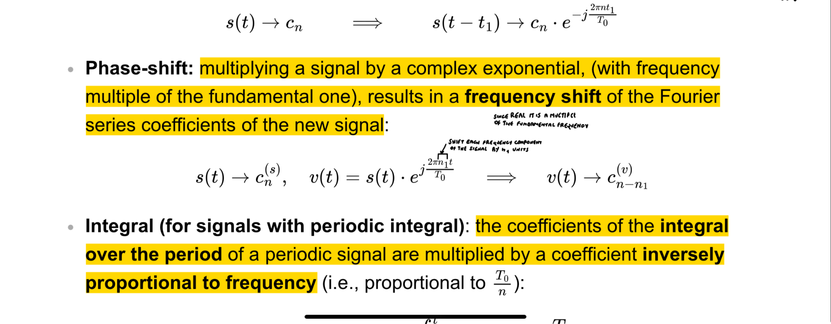
- Phase-shift: multiplying a signal by a complex exponential, (with frequency multiple of the fundamental one), results in a frequency shift of the Fourier series coefficients of the new signal:
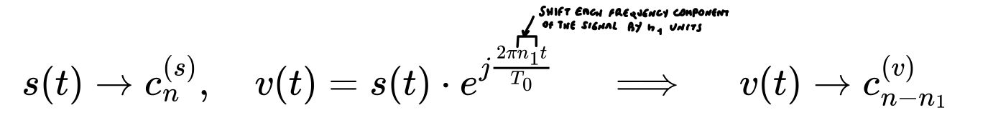
- Integral (for signals with periodic integral): the coefficients of the integral over the period of a periodic signal are multiplied by a coefficient inversely proportional to frequency:
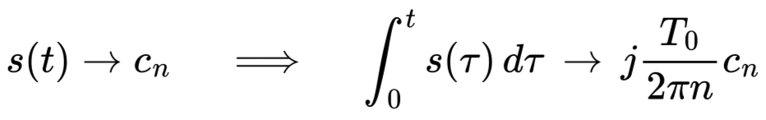
- Derivative (for all signals): the coefficients of the derivative over the period of a periodic signal are multiplied by a coefficient directly proportional to frequency (inverse of what happens with integration):
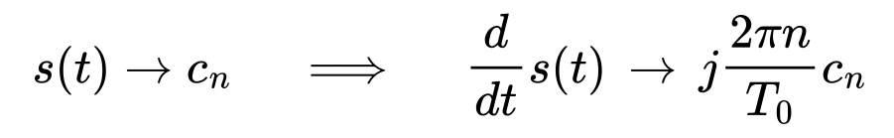

Extract coefficient from difficult signals
If you have a complicated signal, you should follow this procedure to reconstruct its coefficients:
- Decompose the signal into simpler signals, for which you know the expression
- Associate to each of these sub-signals its own coefficients
- Get the coefficients for the whole signal by summing the simpler ones

Example:
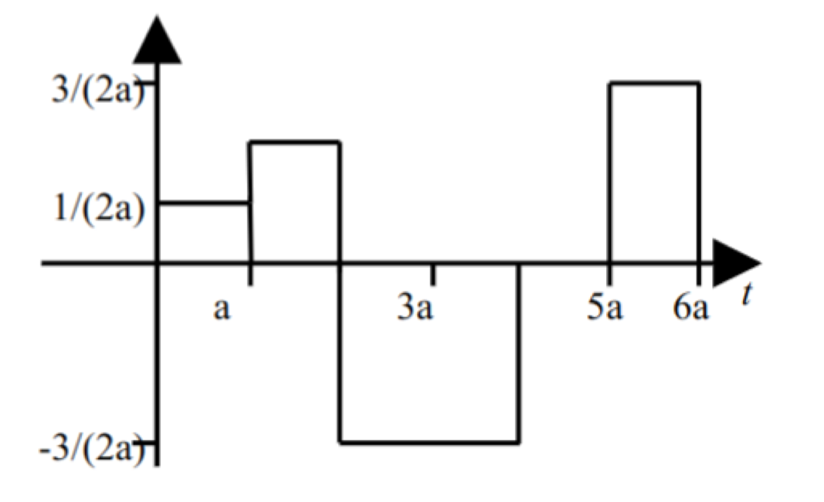
Supposing
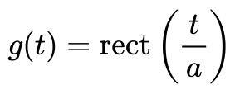
You get that:
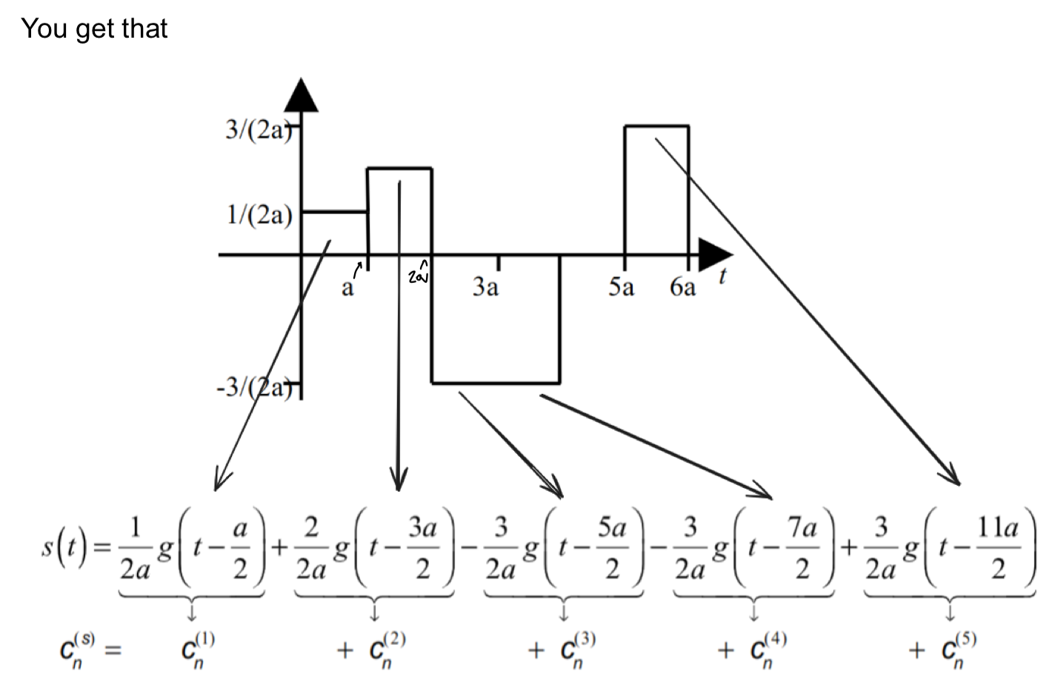
We can see (rect-wave example) that each sub-signal is of the form
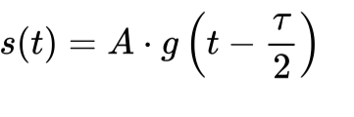
where A is the signal amplitude (height) and 𝜏/2 is half of the signal duration (the time point in the middle of the signal peak).

Transmission of signal (response) in a linear system
Given a linear system of the form:
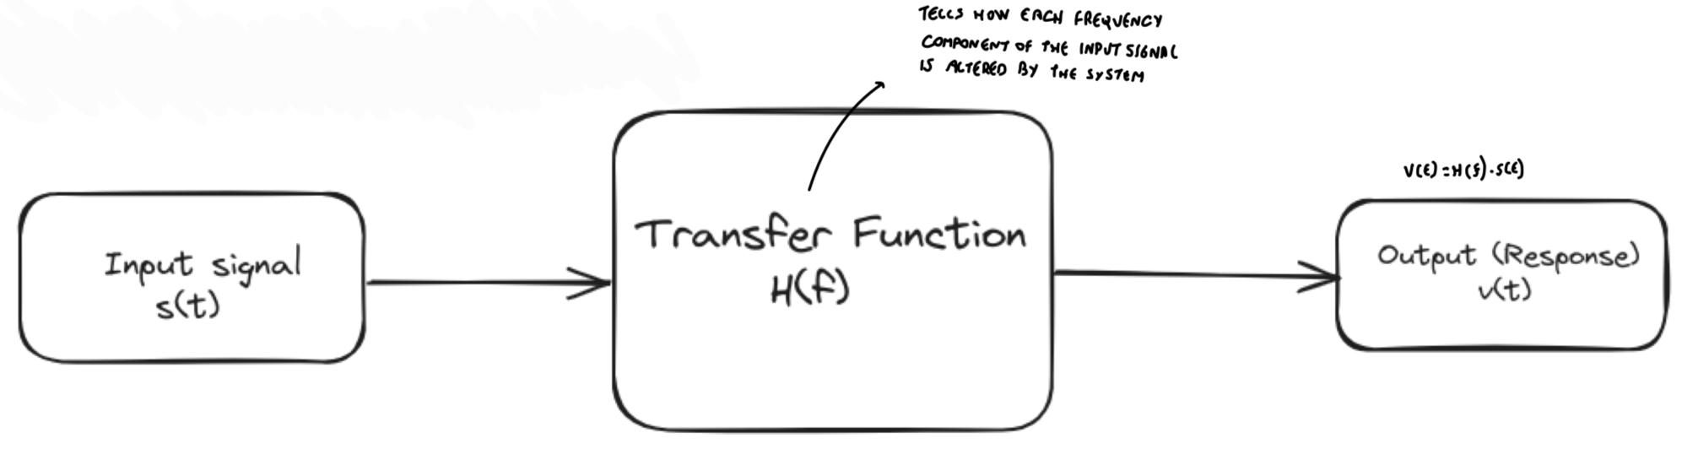
If you have an input signal s(t) and you want to find the output v(t), you apply (multiply) the frequency response (transfer function) H(f) to it.
The response of a linear time-invariant system to a complex exponential function of frequency is the same complex exponential function multiplied by a constant coefficient H(f).

Power of a periodic signal
Assuming a simple periodic signal 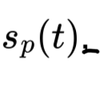, its power is defined as:
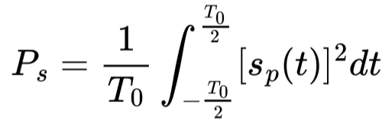
More in general,
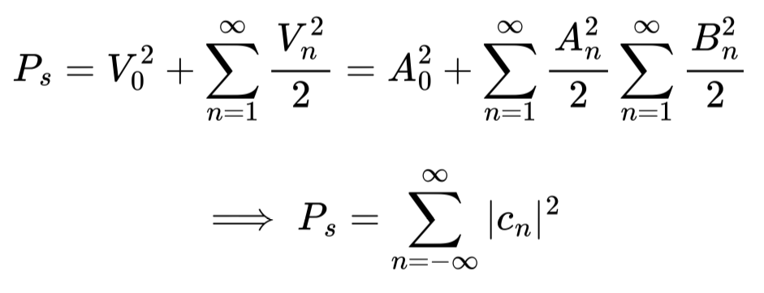
This is called Parseval theorem: the total power is the sum of the power of each component.

Power spectral density
It tell us how the power is distributed over all frequencies:
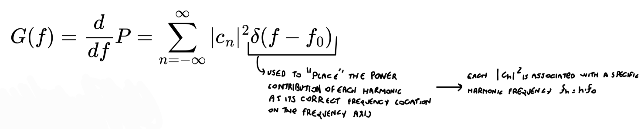
where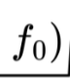the fundamental frequency.
(can be rewritten as 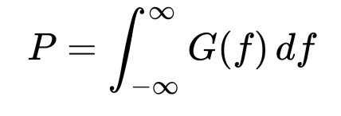)
The total area under the curve of the power spectral density of a power signal is equal to the average power of that signal.

If we assume we are passing through a linear system, the output spectral density will be given by:
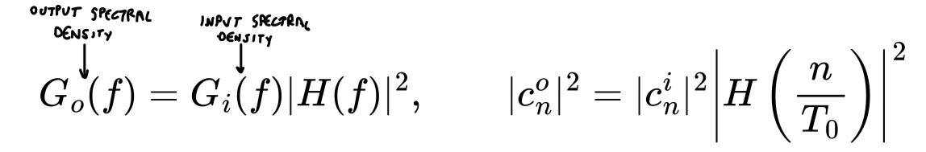

Fourier transform
Given an aperiodic signal s(t), expressed as some function of time t, we can write it as:
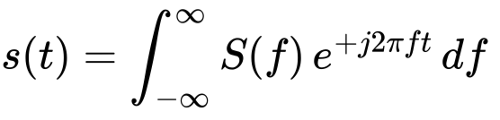
where
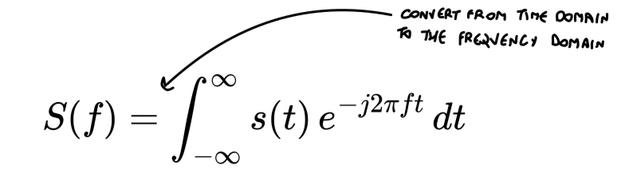
is called Fourier transform of s(t) and it is a complex-valued function. Conversely, the signal s(t) is called antitransform or inverse transform (together, s(t) and S(f) are called Fourier pair). The exponential term 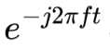is called kernel of the transform formula.
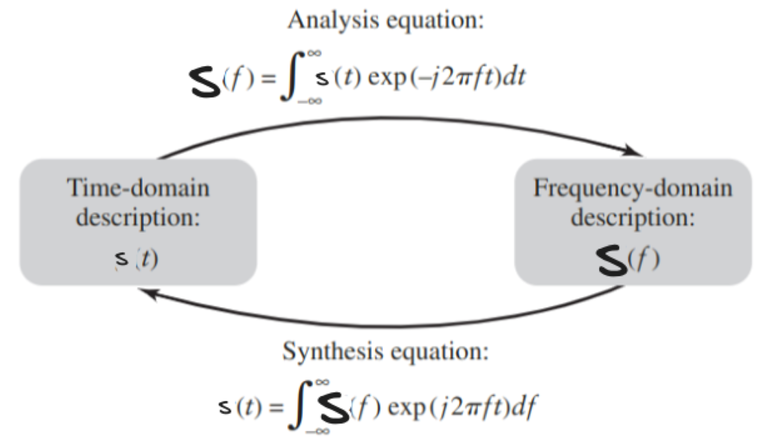
Fourier transform is a fundamental formula to get from a time domain to a frequency domain and vice versa.
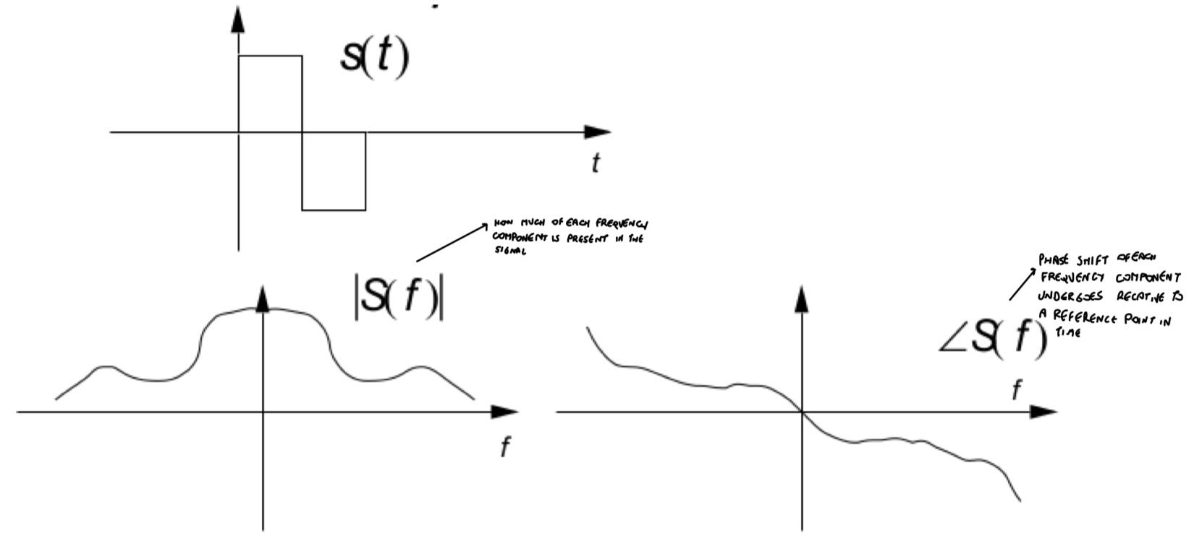

Comparison with Fourier series
Unlike the Fourier series, there are no special frequencies (harmonics) → all frequencies contribute (f is a continuous variable)

The coefficients c_{n} of a periodic signal are easily obtained from the transform of the aperiodic signal s(t) that corresponds to a single period:
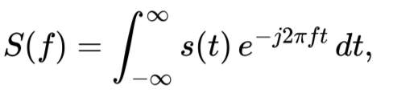
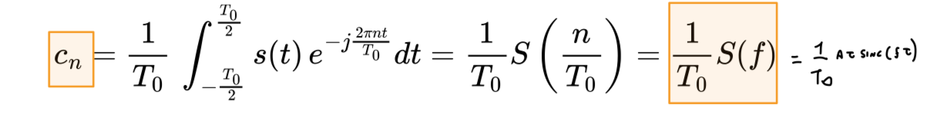
(note that we can go from the integral in the period to the integral over infinity since we use an aperiodic signal for integral over infinity)

Properties of Fourier transform
- Linearity: the transforms of the linear combination of two aperiodic signals are equal to the linear combination of the transforms of the original signals:
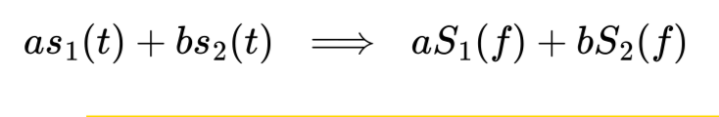
- Delay/anticipation: the transform of a time-shifted signal is equal to the transform of the original signal multiplied by a complex exponential (it is phase-shifted):

- “Phase-shift” (frequency shift): multiplying a signal by complex exponential, (with frequency multiple of the fundamental one), results in a frequency shift of the Fourier transform of the new signal
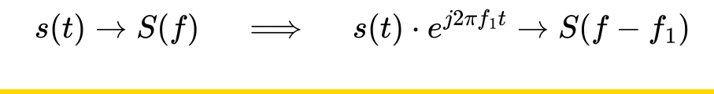
- Integral: the transform of the integral over the period of signal are multiplied by a factor of 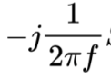 , inversely proportional to frequency:
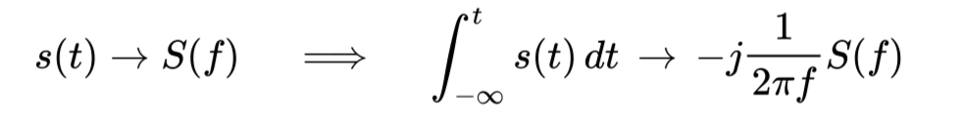
- Derivative: the transform of the derivative over time of a signal is multiplied by a complex coefficient directly proportional to frequency (inverse of what happens with integration):
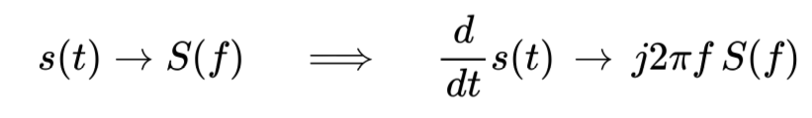

! Cosine multiplication: multiplexing in frequency

Utility of many frequencies
In TLC multiple frequencies are used to manage multiple signals.
- Frequency Division Multiple Access (FDMA): when you transmit multiple signals at the same time, as a composite signal, using different frequency bands for each signal. The different signal components are then separated at the receiving end.
- Frequency Division Duplex (FDD): when you transmit different signals simultaneously, at different frequencies (like in FDMA), in both directions (forward and backward)
- Frequency Reuse in Cellular Lines: cellular networks can be divided into cells, each of which uses a set of frequencies to avoid interference with close cells. These frequencies can be reused in distant cells to maximize bandwidth.
- GSM (2G): use pattern of frequency reuse where each frequency is shared among cells but is distant enough to avoid interference (4/12: reuse every 4th cells in a set of 12)
- LTE (4G): use “soft reuse” to allow for a more dynamic allocation of frequencies

Convolution
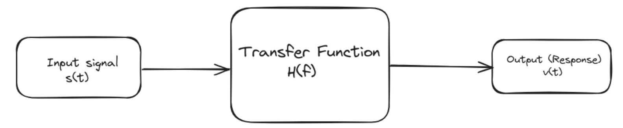
Analogously to Fourier series, passing an input signal x(t) through a linear system corresponds to multiplying its transform by the block’s transfer function H(f):
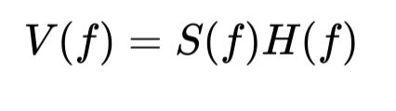
In the time domain, this corresponds to applying the convolution between s(t) and the antitransform of H(F), h(t) which we call impulse response:
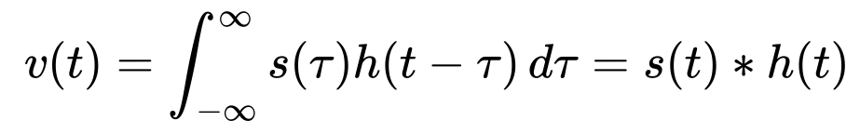
The Fourier transform of convolution of two functions is equal to the product of their Fourier transforms (Convolution Theorem).
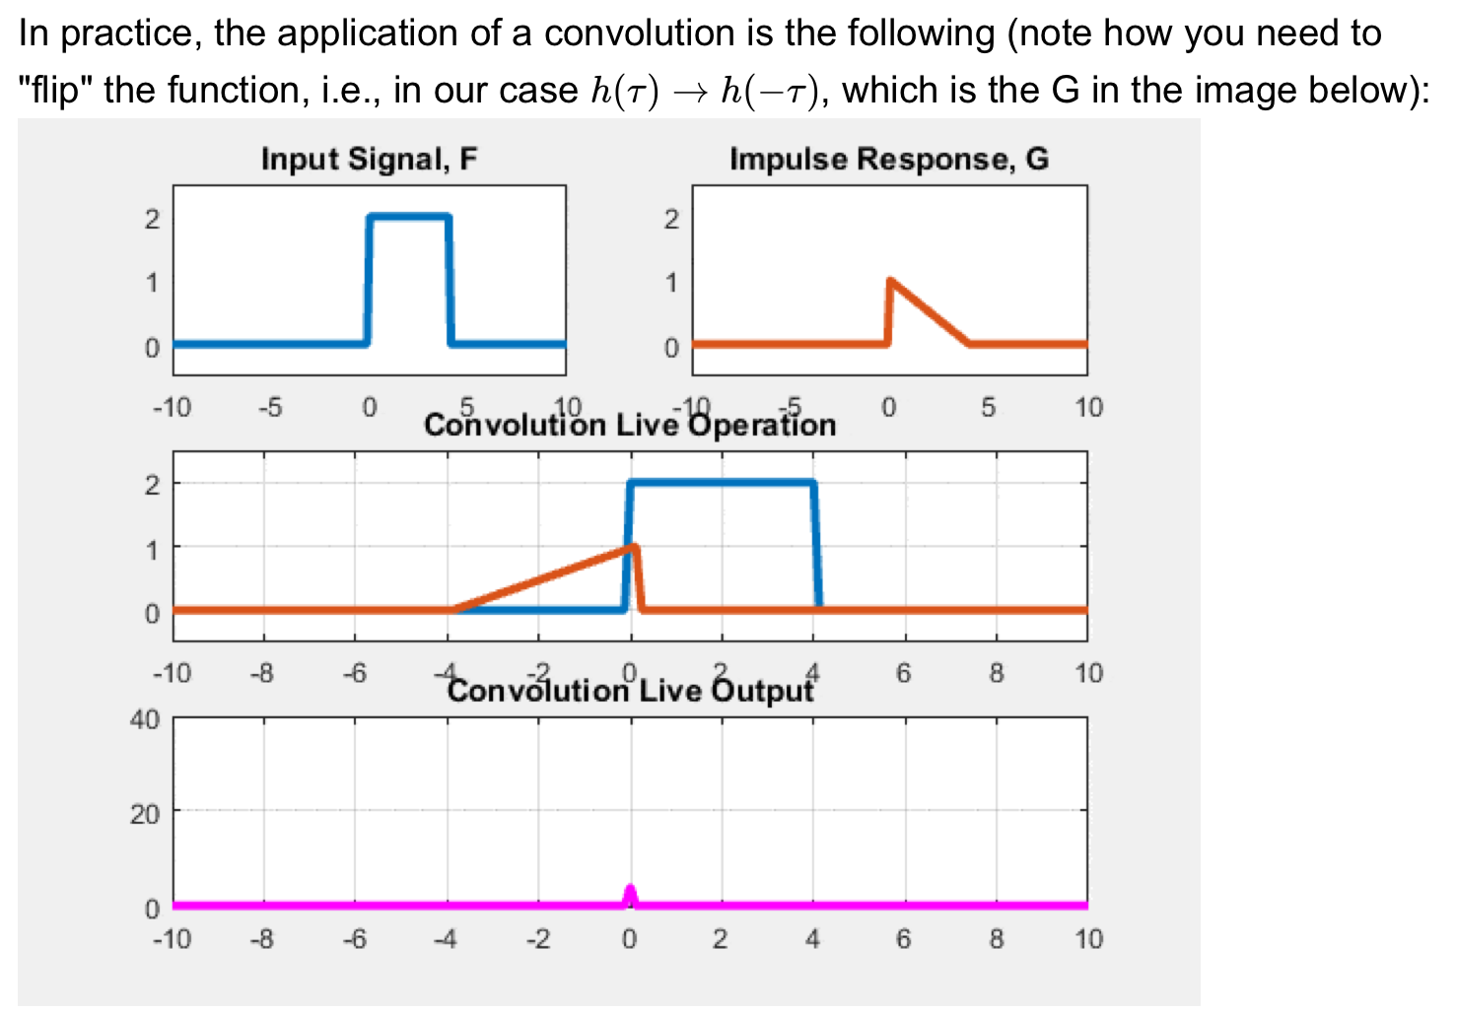
If the input signal of the system, s(t) is equal to Dirac’s delta, i.e. s(t) = 𝛿(t), we get:
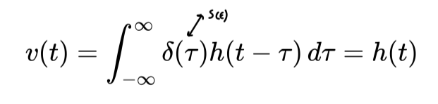
(The convolution between a function and Dirac’s delta is the function itself).

! Energy (Parseval theorem)

Energy through a linear block
- In the frequency domain, if an input passes through a linear system (block), we have a product (Y(f) = H(f)S(f))
- In the time domain, if an input passes through a linear system (block), we have a convolution operation (y(t) = s(t) ∗ h(t))

The spectral density of energy at the output 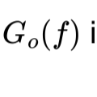 is related to the spectral density at the input 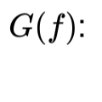:
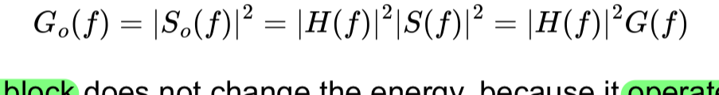
→ then, a delay block does not change the energy, because it operates only on the phase:
→ in contrast, a block that does not change the shape of the output signal can change its energy (e.g. amplifier):
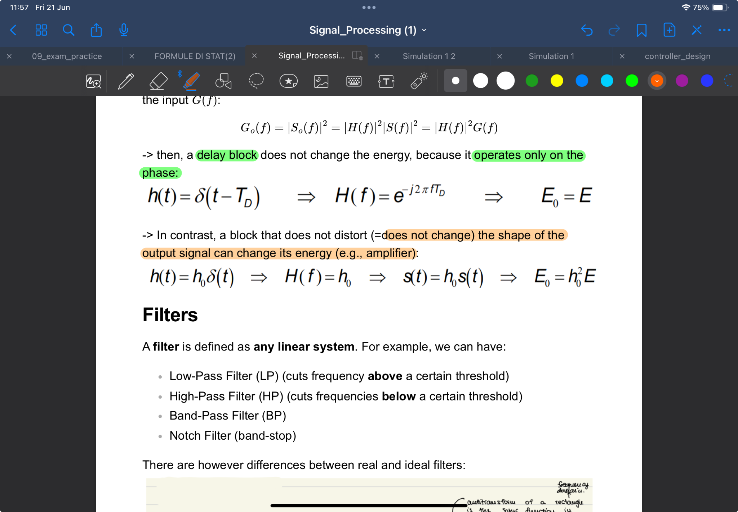

Filters
A filter is defined as any linear system. We can have:
- Low-Pass Filter (LP) → cuts frequency above a certain threshold
- High-Pass Filter (HP) → cuts frequency below a certain treshold
- Band-Pass Filter (BP)
- Notch Filter (band-stop)

There are differences between real and ideal filters:
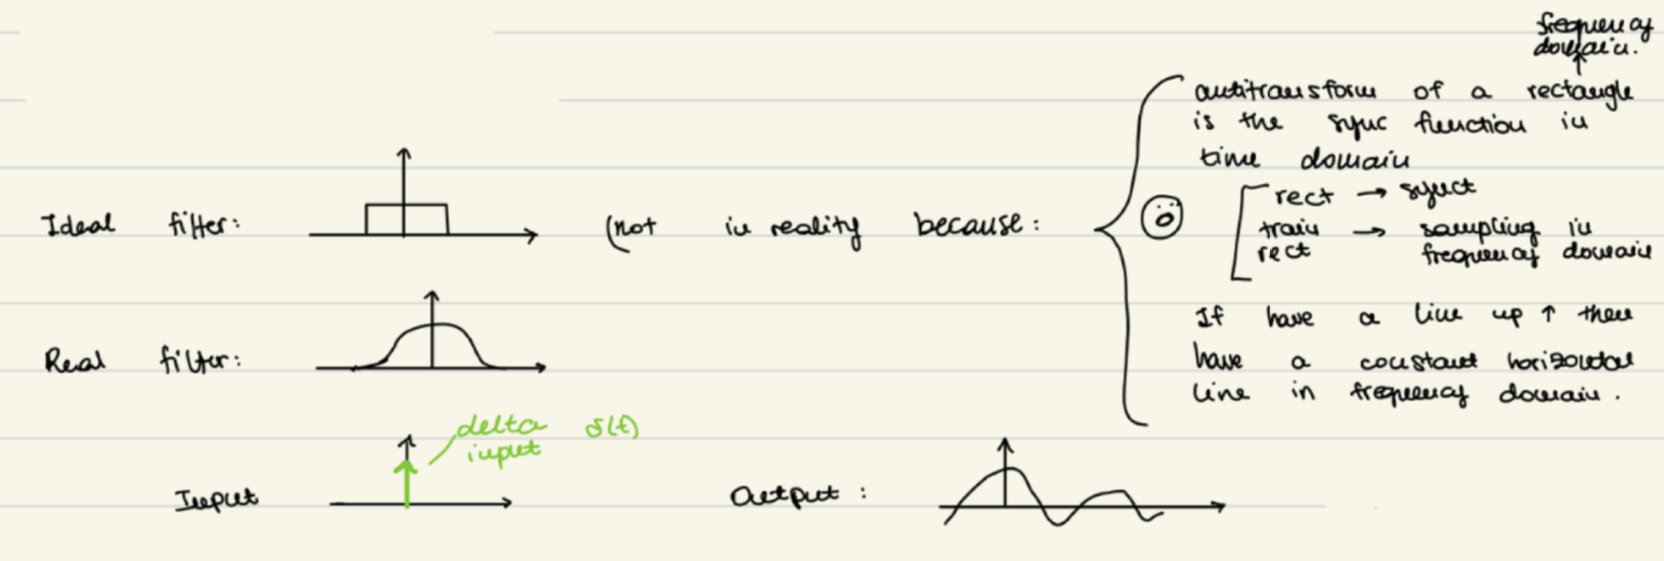

We cannot have a rectangular ideal filter, because the output to a 𝛿(𝜏) impulse response would be shaped in such a way that the output signal would start at a time before the input impulse.

Correlation
Correlation measures the degree of similarity between two signals. It is similar to convolution.
- For aperiodic signals, correlation is defined as:
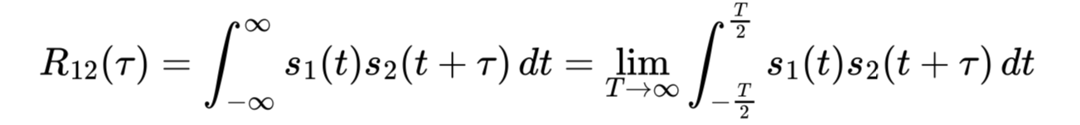
- For periodic signals, we simply add a division by the period T₀:
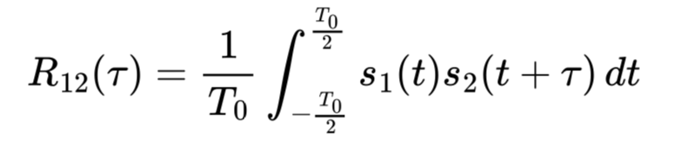

Correlation for delay calculation
If I transmit a signal s(t), and the signal arrives after a delay 𝛼, I can use correlation to calculate the delay
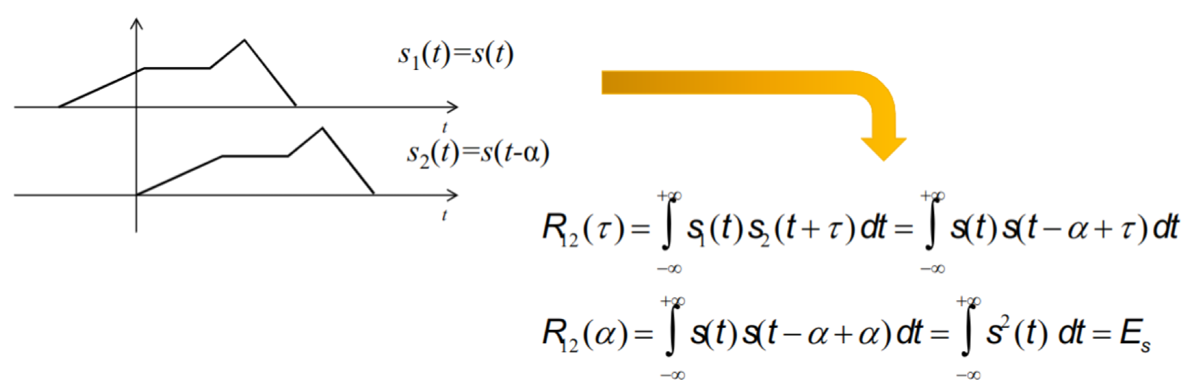

Correlation and Power (Energy)
Correlation is also used to calculate the double product, in the context of calculating the energy of the sum of two signals (which is the square of the sum).

The power of their sum is given by:
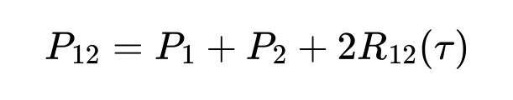
→ if two signals are uncorrelated (R₁₂ = 0), then the energy of their sum is the sum of their energies.
→ otherwise, there is an additional term which accounts for the similarity between the signals.

Autocorrelation
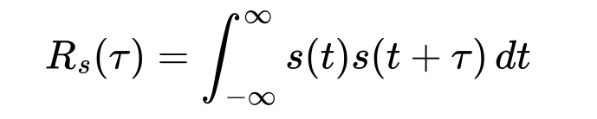
Autocorrelation is the correlation of a signal with itself shifted. It is the integral of the product between a signal and the signal itself shifted.

Autocorrelation in time and energy spectral density are a Fourier pair.

There are three fundamental properties of autocorrelation
- R_{s}(𝜏) with 𝜏 = 0 has the maximum autocorrelation:
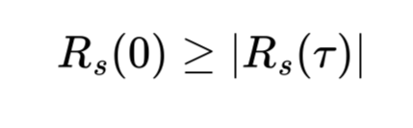
- The maximum autocorrelation is equal to the energy:
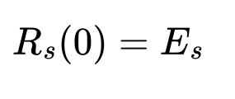
- Autocorrelation is an even (symmetric) function:
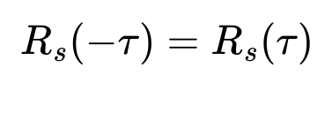
(NOTE: in the case of a power signal, similar conditions apply, but with power instead of energy)

To sum up the difference between convolution, correlation and autocorrelation:
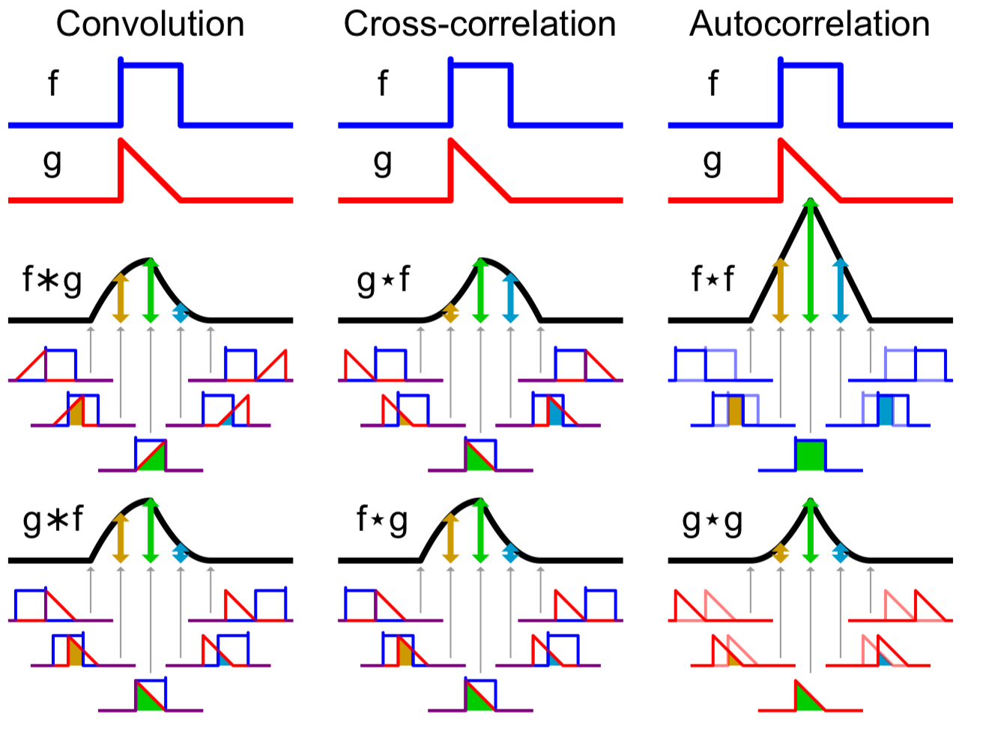

Autocorrelation of a periodic signal
Even in the case of a periodic signal, autocorrelation and power spectral density are a Fourier pair (to get power spectral density you have to apply the Fourier transform to autocorrelation).

When we consider the result of a linear system applied to a signal, i.e., the application of a transfer function, product in the frequency domain corresponds to convolution in the time domain.

Random signals
For signals, if we have as input to a block a random variable, the transformations are applied to the distribution of the random variable:
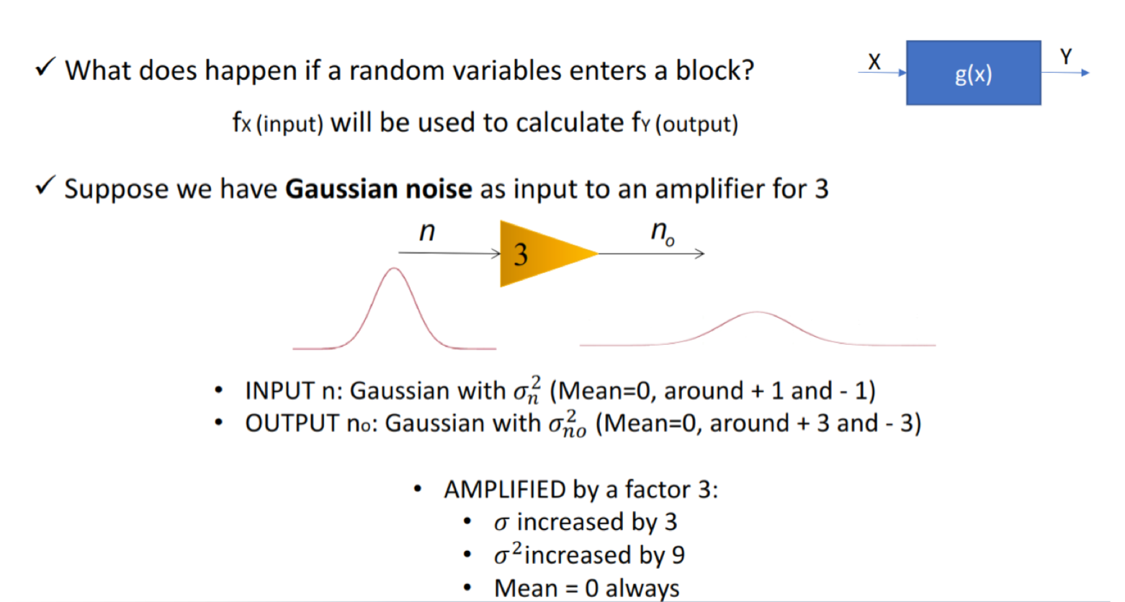

Random process
A random process is a relationship that links the random (not possible to predict exactly or deterministically) outcome of an experiment to a function in time.

We can have
- time-continuous random processes, which have the following realization (or sample function):
- time-discrete random processes, which have the following realization (sample function):
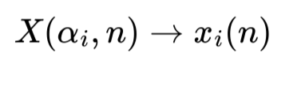

NOTE:
- For fixed i, the signal x_{i}(t) or x_{i}(n) is not random, but deterministic
- At fixed t, and thus X_{t} = X(t) is a random variable.
- The family of all these random variables forms the random process.

Since X_{t} = X(t) is a random variable, we can define a cumulative distribution function for it:
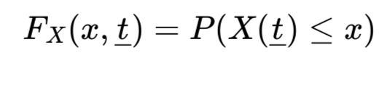
This CDF however, is not sufficient, since sometimes you will need to know what happens to the process at time t₁ and t₂:
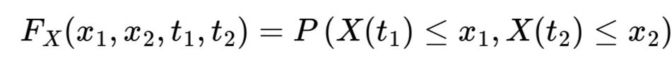
→ you need to know the joint (second-order) CDF.
In general you will need knowledge of the cumulative probability function of order m, for every possible m.

Random process statistical indices
We can model the process by considering only some meaningful statistical measures:
- Mean:
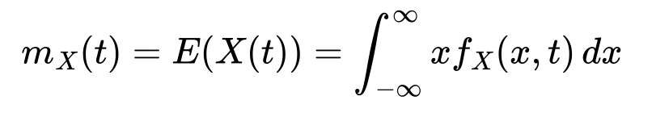
where

- Power (mean of the squared signal):
